HW03
Due on February 29, 2024 by 11:59 PM
William Charles Wenzel

Problem 1 (10pts)
Consider a plant $G\left(s\right)=\frac{K}{Js^{2}+cs}$ with K=450, J=8, c=4.
  - Design a unit feedback closed loop system and derive its transfer function TF_{CL}(s).
We start with: $G\left(s\right)=\frac{K}{Js^{2}+Cs}=\frac{450}{8s^{2}+4s}$
$$TF_{CL}\left(s\right)=\frac{G\left(s\right)}{1+G\left(s\right)H\left(s\right)}$$
But, with H(s)=1,
$$TF_{CL}\left(s\right)=\frac{G\left(s\right)}{1+G\left(s\right)}=\frac{\frac{450}{8s^{2}+4s}}{1+\frac{450}{8s^{2}+4s}}=\frac{450}{8s^{2}+4s+450}$$

  - Plot the block diagram your design.
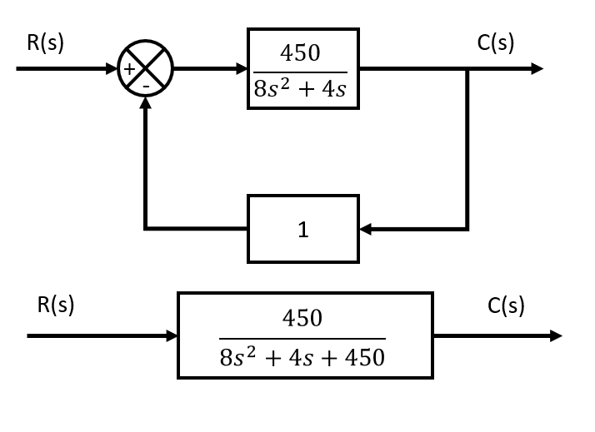
  - Find the poles of closed loop system
Standard form of 2nd order system: $G\left(s\right)=\frac{ω_{n}^{2}}{s^{2}+2ζω_{n}s+ω_{n}^{2}}$
$$TF_{CL}\left(s\right)=\frac{450}{8s^{2}+4s+450}$$
To convert to standard form, the variable in the 2nd order position mut be equivalent to 1. Thus, the following:
$$G\left(s\right)=\frac{56.25}{s^{2}+0.5s+56.25}$$
And we get: $ω_{n}=\sqrt{56.25}=7.5, ζ={0.5}/{2*7.5}=1/{30}$
Now, we can find the pole placement via the standard form for the pole placement of a 2nd order system.
$$p_{1,2}=-ζ⋅ω_{n}±j⋅ω_{n}*\sqrt{1-ζ^{2}}$$

$$p_{1,2}=-\frac{1}{30}⋅7.5±j⋅7.5*\sqrt{1-{\left(\frac{1}{30}\right)}^{2}}$$
$$p_{1,2}=-0.25±j⋅7.5*\sqrt{1-\frac{1}{900}}$$
$$p_{1,2}=-0.25±j⋅7.4958$$
  - Derive & plot the step response of the original system
$$Y\left(s\right)=G\left(s\right)⋅U\left(s\right)=\frac{450}{8s^{2}+4s}*\frac{1}{s}=\frac{450}{8s^{3}+4s^{2}}$$
From MATLAB: $y\left(t\right)=\frac{225}{2}-\frac{225⋅e^{-\frac{t}{2}}}{2}$
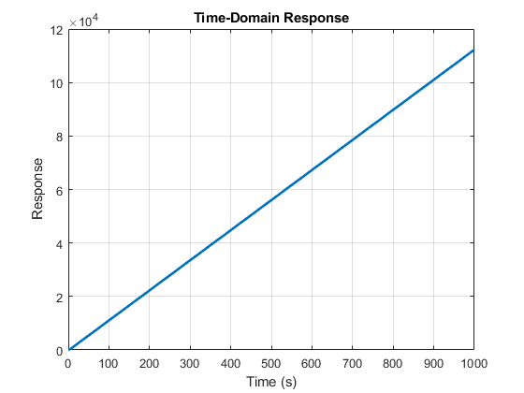
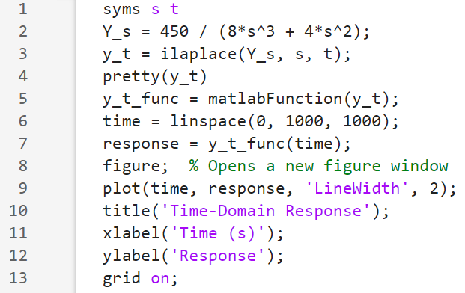

  - Derive & plot the step response of the closed loop system
The system step response is represented by
$$Y\left(s\right)=TF_{CL}\left(s\right)⋅U\left(s\right)=\frac{450}{8s^{2}+4s+450}*\frac{1}{s}=\frac{450}{8s^{3}+4s^{2}+450s}$$
We find $y\left(t\right)=1-e^{-\frac{t}{4}}\left(\cos\left(\frac{\sqrt{899}t}{4}\right)+\frac{\sqrt{899}}{899}⋅\sin\left(\frac{\sqrt{899}t}{4}\right)\right)$
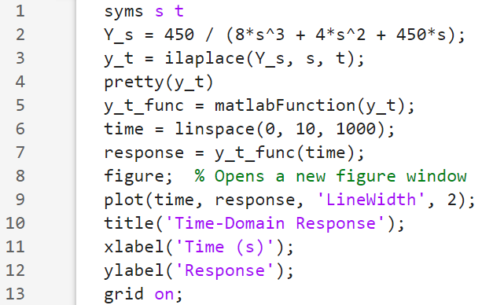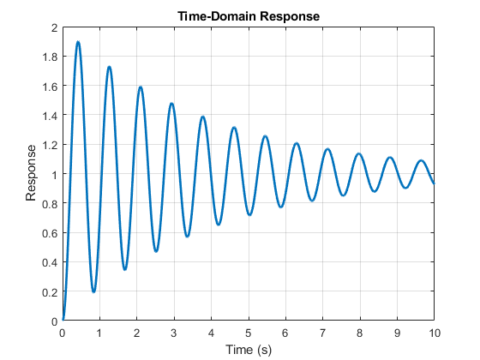

  - Use the Closed Loop step response plot to estimate the rise time 10% to 90% t_{r},

After looking at 13 individual Control Systems textbooks, I found 2 approximations that work well enough with a very low angle or damping factor.

From Feedback Systems, An Introduction for Scientists and Engineers 2nd:
$$T_{r}=\frac{e^{\frac{φ}{\tan\left(φ\right)}}}{ω_{0}}, where φ=\arccos\left(ζ\right) [ω_{n}=ω_{0}, just different notation]$$
And from Automatic Control Systems 10th,
$$t_{r}=\frac{1-0.4167ζ+2.197ζ^{2}}{ω_{n}}$$
Both solutions yield results close to the numerical results, being:
$0.1403 seconds \& 0.1319 seconds$ respectively compared to the numerical 0.139 seconds.
  - and the percentage overshoot, M_{p}.
$$M_{p}=e^{-\frac{ζ}{\sqrt{1-ζ^{2}}}π}=e^{\left(- \frac{\frac{1}{30}}{\sqrt[2]{1-{\left(\frac{1}{30}\right)}^{2}}}\right)π}≈0.9=90\%$$

  - Show snips of the plot with data cursors showing the measurements; write the estimated results for t_{r} and M_{p}
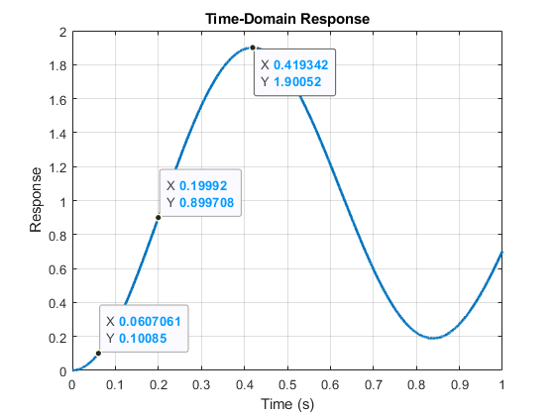
$$M_{p}=\frac{01.90052-1}{1}=90.052\%$$
$$t_{r}=0.19992-0.0607061=0.139 seconds$$

Problem 2
- find the poles of the feedback control system: (15pts)
$G(s)=\frac{5s+1}{2s+3}$ and $H(s)=\frac{5(s+2)}{s+10}$
The Transfer function of the Closed loop system can be found via $Y\left(s\right)=\frac{G\left(s\right)}{1+G\left(s\right)H\left(s\right)}$
$$Y\left(s\right)=\frac{\frac{5s+1}{2s+3}}{1+\frac{5s+1}{2s+3}*\frac{5(s+2)}{s+10}}=\frac{\left(s+10\right)\left(5s+1\right)}{\left(3s+2\right)\left(9s+20\right)}$$
Thus, the poles are: $s=-\frac{2}{3}≈0.66, s=-\frac{20}{9}≈-2.22$

- Calculate the steady state error for a unit feedback system with plant given below for step input (5pts) and ramp input (10pts), respectively.
$$G(s)=\frac{3s^{2}+4s+83}{16s^{7}+9s^{5}+17s^{4}+6s}$$

There are 2 solutions. Following the traditional definition, $e_{ss}=\lim_{t→∞}{e\left(t\right)}=\lim_{s→0}{s⋅E\left(s\right)}$ where E(s) is equivalent to the total transfer function of the system, not just the plant.

However, considering the transfer function of a unity feedback closed loop system can be found via $E\left(s\right)=\frac{G\left(s\right)}{1+G\left(s\right)}$, we can also solve for error with just the plant function.

We get $e_{ss}=\lim_{t→∞}{e\left(t\right)}=\lim_{s→0}{s⋅E\left(s\right)}=\lim_{s→0}{\frac{s⋅R\left(s\right)}{1+G\left(s\right)}}$, where R(s) is the input function.

For a step input r(t) with magnitude R, $R\left(s\right)=\frac{R}{s}$, thus $e_{ss}=\lim_{s→0}{\frac{s}{1+G\left(s\right)}⋅\frac{R}{s}}=\lim_{s→0}{\frac{R}{1+G\left(s\right)}}=\frac{R}{1+\lim_{s→0}{G\left(s\right)}}$

For convenience of solving, we set the limit to a variable called $K_{p}$ where p represents “position”.
$$K_{p}=\lim_{s→0}\left(G\left(s\right)\right), where e_{ss}=\frac{R}{1+K_{p}}$$
And for a traditional step or ramp input, R=1.
$$K_{p}=\lim_{s→0}\left(\frac{3s^{2}+4s+83}{16s^{7}+9s^{5}+17s^{4}+6s}\right)=\left(\frac{83}{0}\right)=∞$$
$$e_{ss}=\frac{1}{1+∞}≈0$$

For a ramp input r(t) with slope R, $R\left(s\right)=\frac{R}{s^{2}}$, thus $e_{ss}=\lim_{s→0}{\frac{s}{1+G\left(s\right)}⋅\frac{R}{s^{2}}}=\lim_{s→0}{\frac{R}{s+s⋅G\left(s\right)}}=\frac{R}{\lim_{s→0}{s⋅G\left(s\right)}}$
*Note that the additional “s” is removed since we can assume it goes to 0 from the limit.
For convenience of solving, we set the limit to a variable called $K_{v}$ where v represents “velocity”.
$$K_{v}=\lim_{s→0}\left(s⋅G\left(s\right)\right), where e_{ss}=\frac{R}{K_{v}}$$
$$K_{v}=\lim_{s→0}\left(\frac{s⋅(3s^{2}+4s+83)}{16s^{7}+9s^{5}+17s^{4}+6s}\right)=\lim_{s→0}\left(\frac{s⋅(3s^{2}+4s+83)}{s⋅\left(16s^{6}+9s^{4}+17s^{3}+6\right)}\right)=\frac{83}{6}$$
*Note, $\lim_{s→0}\left(\frac{s}{s}\right)=1$
$$e_{ss}=\frac{1}{\left({83}/6\right)}=\frac{6}{83}$$
Problem 3: Use Routh criterion to evaluate the stability of the following systems. You must show step by step derivation. (20pts)

- $s^{5}+2s^{4}+2s^{3}+4s^{2}+11s+10=0$

- $s^{3}+s^{2}+2s+2=0$

Problem 4
- Use Routh criterion to find the stability range of K for the feedback control system illustrated below. Show your hand derivation step by step. (15pt)

$G\left(s\right)=\frac{1}{(s+2)(s+8)}$, $H\left(s\right)=K+\frac{12K}{s}$

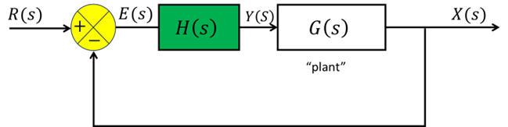

- Set a value for K and plot the step response for the feedback system for case (a) not meeting the design requirement and case (b) meeting the design requirement. Please mark in your plots the value of K you select for the plots. (5pts)

Problem 5 Root locus method
- Derive (not by software tool) the root locus of the system given below. You need to show your work on the five essential steps. With the results, try hand sketch the RL. (10pts)
$$G\left(s\right)=\frac{K}{(s+2)(s+1)(s+4)}$$
Poles and zeros including if you have infinite zeros:
# of branches
Real axis segment(s)
Breakaway points in real axis
Asymptotes locations and angles if deemed needed

- Now use MATLAB rlocus() function to plot the RL. Paste your codes and resulting plot below. (5pts)

- We need to design a controller that satisfies $t_{r}<1 s$, $M_{p}<5\%$. Draw the geometric constrains on your RL plot. You can use MATLAB to do so (hint: sgrid()) or use drawing tool. Please mark clearly the values in the plot. And show where are the applicable root loci range. You can do so by using drawing tool.
In the identified range, choose a locus point and identify the K value. Find and plot the step response with this K value of the control system. (5pts)

